(Before analysis)Decisions I made:

1 ). I choose zero_R method to implement the baseline model.

Because this is the most commonly-used baseline in machine learning, and it is pretty easy to implement

2 ). Also make all the instances as both training set and test set

I tried both using no test data(use all data for both training and evaluating) and splitting data in to 80% training and 20% testing. The results are quit similar, and using no test data can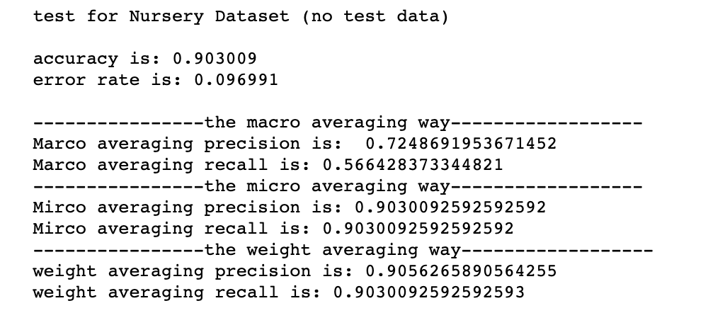 see the performance of the model more clearly.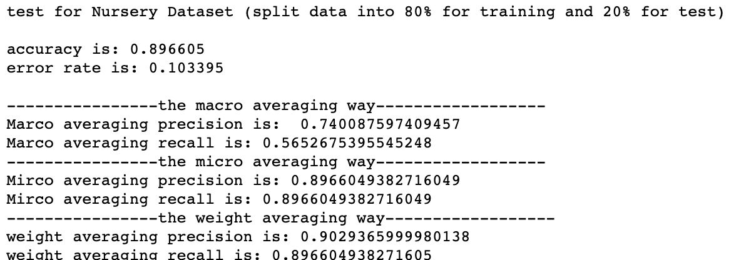

(Evaluation result of nursery.data)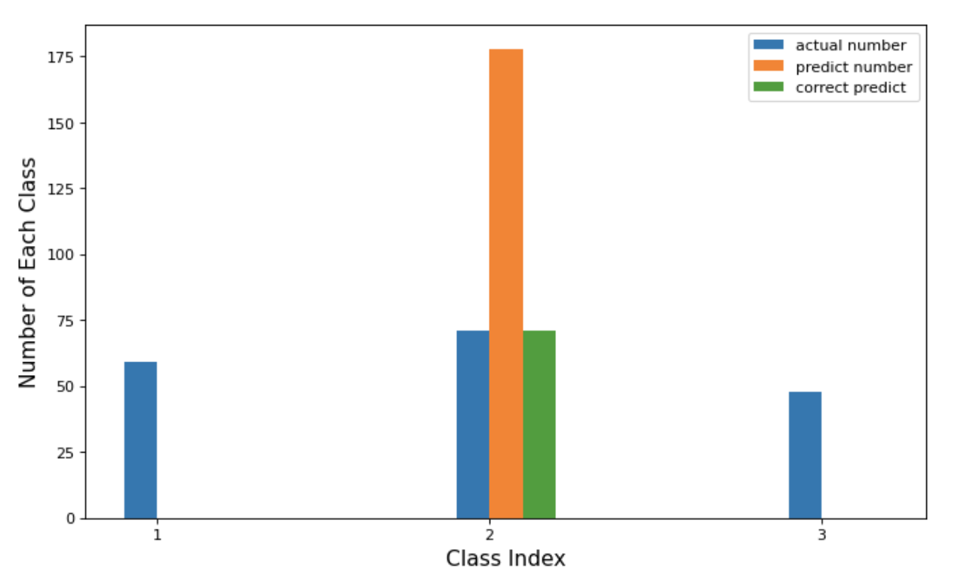

**Analysis:**

**First Half Question(baseline part)**

This baseline model(0R) classify all instances as the most common class in the training data.

We can see the how the actual number for each class, and how predict one work on the right. (this dataset choose class 2 as predict class)

Because how this model works, the performance of the model is totally depends on how classes distributed.

**Factor 1**

The most intuitive reason that affect the performance is the proportion of the highest frequency class in the entire dataset.

———————————————————————————————————————————

If the percentage is high, The accuracy is high.

Theoretically, (if the test distribution is the same to the training distribution)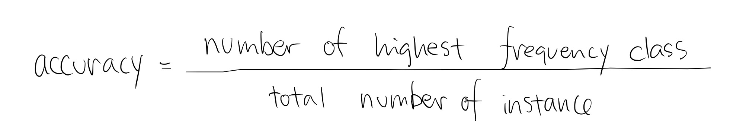

In practice, If I use no test data to evaluate the data, the accuracy is exactly equal to the the proportion of the highest frequency class. (the results for splitting data in 8:2 are also pretty similar). Example: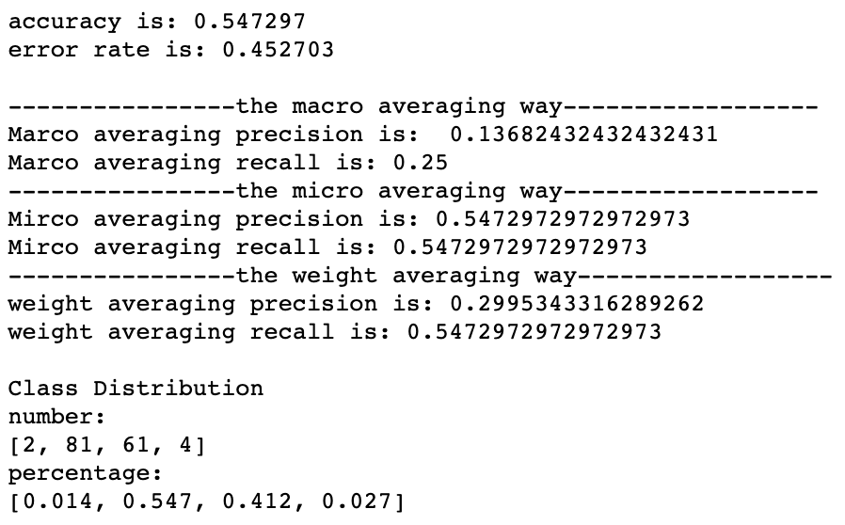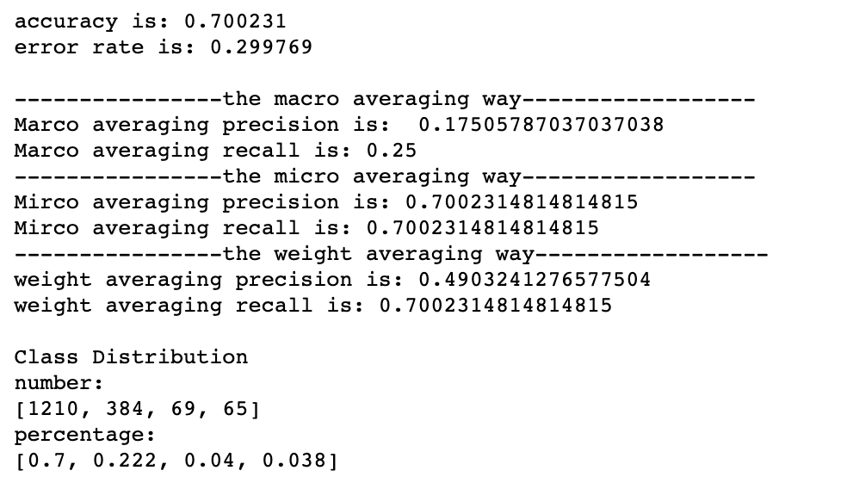

The evaluation result of car.data

The evaluation result of lymphography.data

In the evaluation result of car.data, there are 4 type of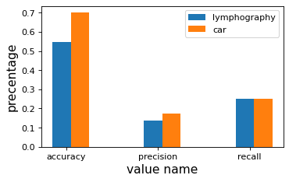 class unacc, acc, good, v-good. The number of instance that the class is unacc is much larger than other 3 class, The percentage is higher, so that the accuracy is higher.

In the evaluation result of lymphography.data, there are also 4 type of class (1)normal find,( 2)metastases, (2)malign lymph, (4)fibrosis. The metastases takes up 55% of entire dataset. It is lower than unacc 70% in car.data.So the accuracy of lymphography is lower than car. (which is also shows in the graph)

Compare evaluation value between lymphography.data and car.data

———————————————————————————————————————————

If the percentage is high, The precision is high.

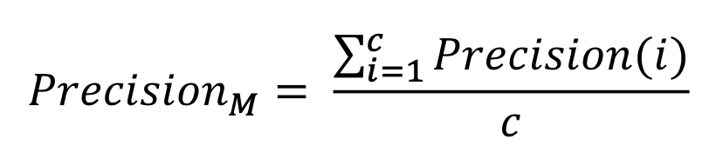

The formula of the precision is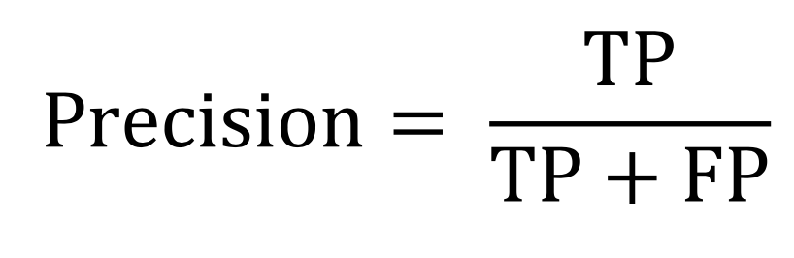

The number of the highest frequency class is the only TP has value in this case. As it increase the precision increase.

In the lymphography.data and car.data example, we can see this is quite obvious (*the precision is in the lined with blue*)

This is also make sense because precision is the value that shows how often is the model correct, when it predicts a positive case. We make the same prediction for the whole dataset with EXACT ONE class, More this class occur in the raw dataset, more accurate the model preform. ———————————————————————————————————————————

If the percentage is high, The recall is also high

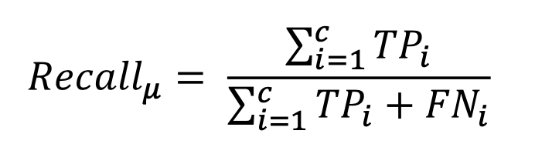

The formula of the recall is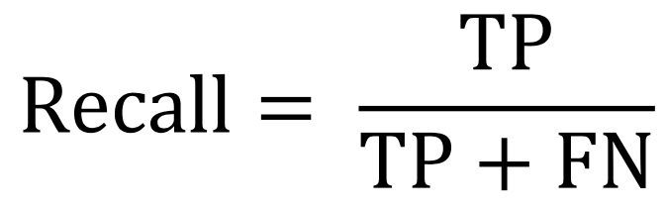

Similar to the precision, according to the formula, The number of the highest frequency class is the only TP has value in this case, As it increase the recall increase.

We can we can see this is for Micro Averaging and Weight Averaging recall. *(In the purple line)*

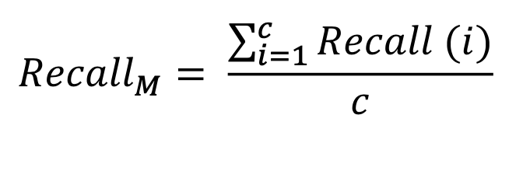

But in this case, Macro Averaging has some issues, cause except all the predict class column, all the other column will be zero. It will cause Number_of_class recall are all 1 (cause there are no False Negative).

So the proportion of the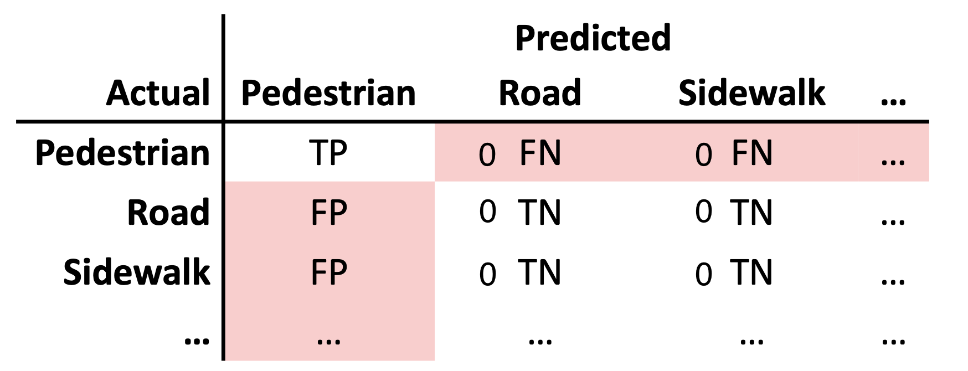 highest frequency class has no effect to Macro averaging precision in 0R baseline model. *(in the pink square)*

**Factor 2**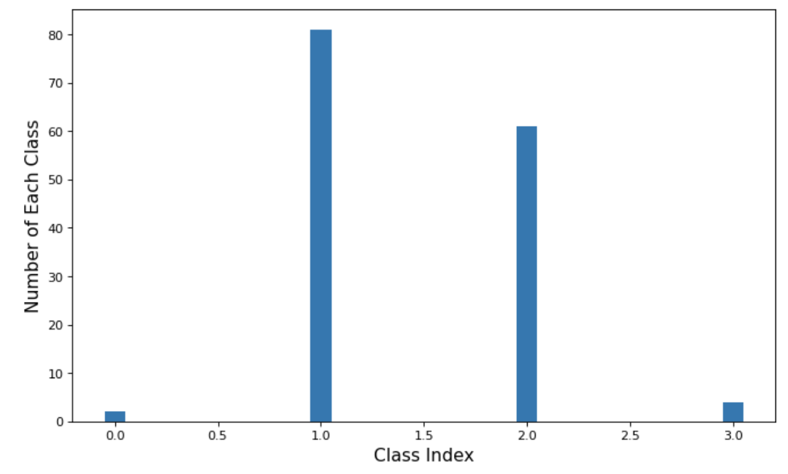

The distribution of number of classes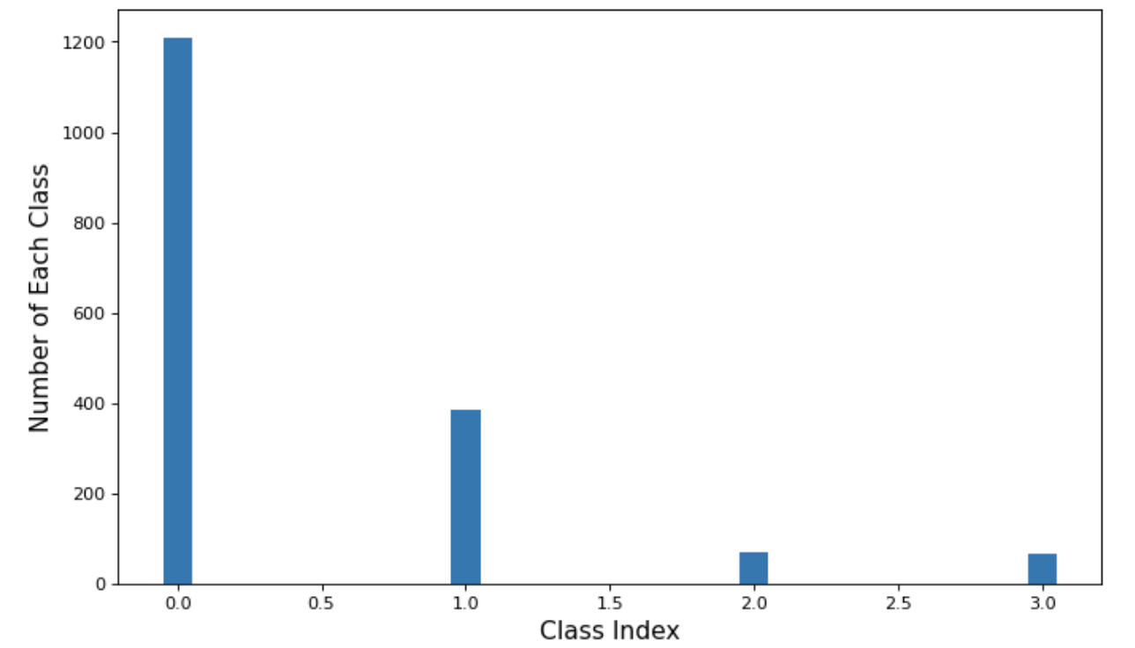

Accuracy = 0.54

Accuracy = 0.7

lymphography.data class distribution

Car.data class distribution

The proportion of the highest frequency class is the key factor that effect the performance of the model, while the distribution of number of classes is the factor to effect the proportion.

In the worst condition, that all classes are uniformly distributed, we have to randomly choose a class as our predict class, the accuracy is 1/number of class type.

Like the lymphography.data is more uniform than the car.data, the accuracy is lower

**Factor 3**

As going further about the proportion of the highest frequency classes, we can observe that number of class also effect the performance

—————————————————————————————————————

If the number of classes is big, accuracy might be lower

Theoretically,

As we see in the factor2, in the worst case, when all classes are uniformly distributed, the accuracy is 1/number of class type.

Like the worst accuracy for 2 type of class is 50%

The worst accuracy for 3 type of class is 33.33%

The worst accuracy for 4 type of class is 20%

……

So the conclusion would be: when the number of different class type is relatively uniformly distributed, the number of class increase, the accuracy decrease.

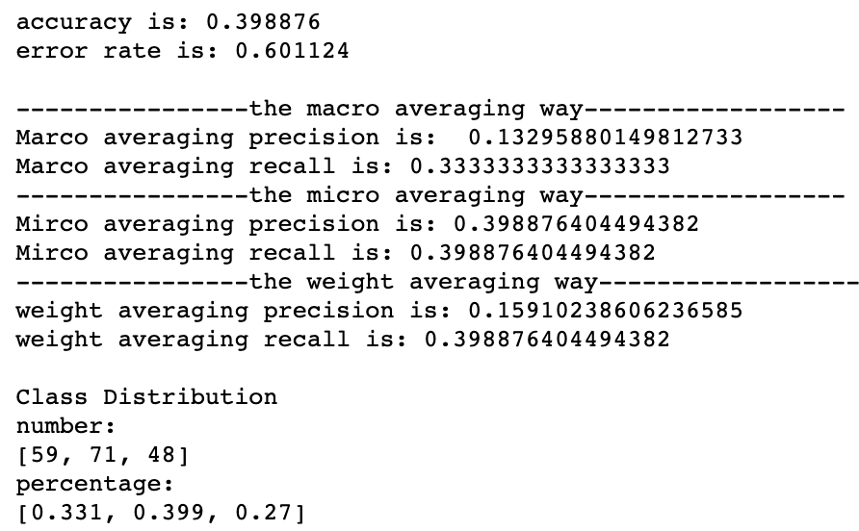

In the practise, the result can also prove that: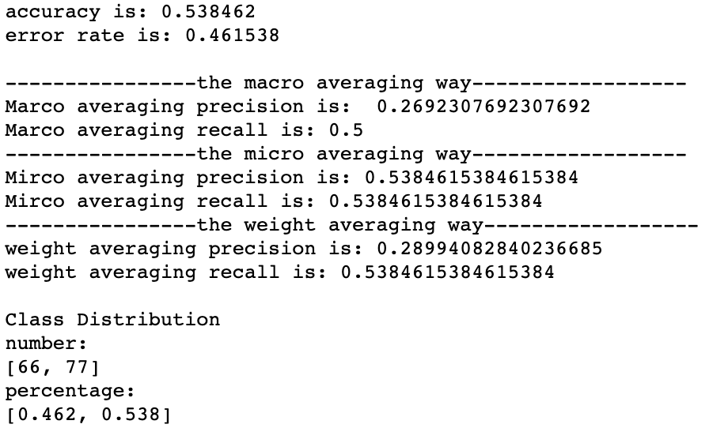

Evaluation result for somerville.data

Evaluation result for wine.datda

Both someville.data and wine.data has 4 type of class and Both number of different class type are relatively uniformly distributed, but the accuracy of Somerville.data is nearly 15% higher than the wine.data.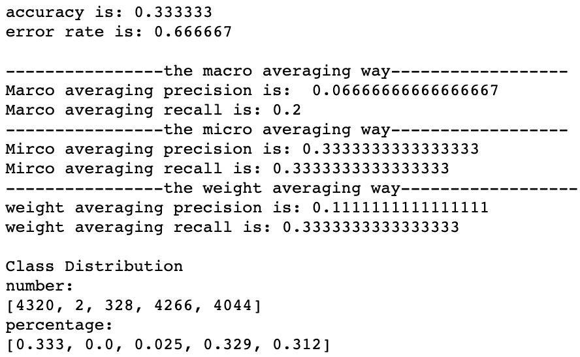

We can also see that the in the nursery.data, there are 5 class type,

The distribution are not uniformly like the wine.data, but it accuracy is 30% lower than the wine.data.

So, the number of class is not a direct cause that effect the accuracy, but it can potentially effect it.

Evaluation result for nursery.data

—————————————————————————————————————

If the number of classes effect the Macro Averaging recall

As we analysis in **Factor 1**. Cause except the predict class column, all the other column will be zero. It will cause Number_of_class recall are all 1 (cause there are no False Neg on ative). So the

RecallM = 1/number_of_class

According to this, Macro Averaging is not a good way to evaluate recall for 0R baseline.

—————————————————————————————————————

If the number of classes is big, precision and recall might be lower

Because the number of class type will potentially effect the accuracy. So, it will potentially effect the number of TP, then the precision and recall will change .

If the number of classes is big, precision and recall might be lower together

**Second Half Question(Naive Bayes improves baseline performance)**

I used the 0R baseline predict the class with the 10 datasets

At the same time, I trained 10 dataset with Naive Bayes classifier, and evaluate the result.

By comparing the results, I can see 3 Improvement points that Naive Bayes classifier has.

—————————————————————————————————————

**Improvement point 1:**

Naive Bayes classifier accuracy is more stable than the baseline.

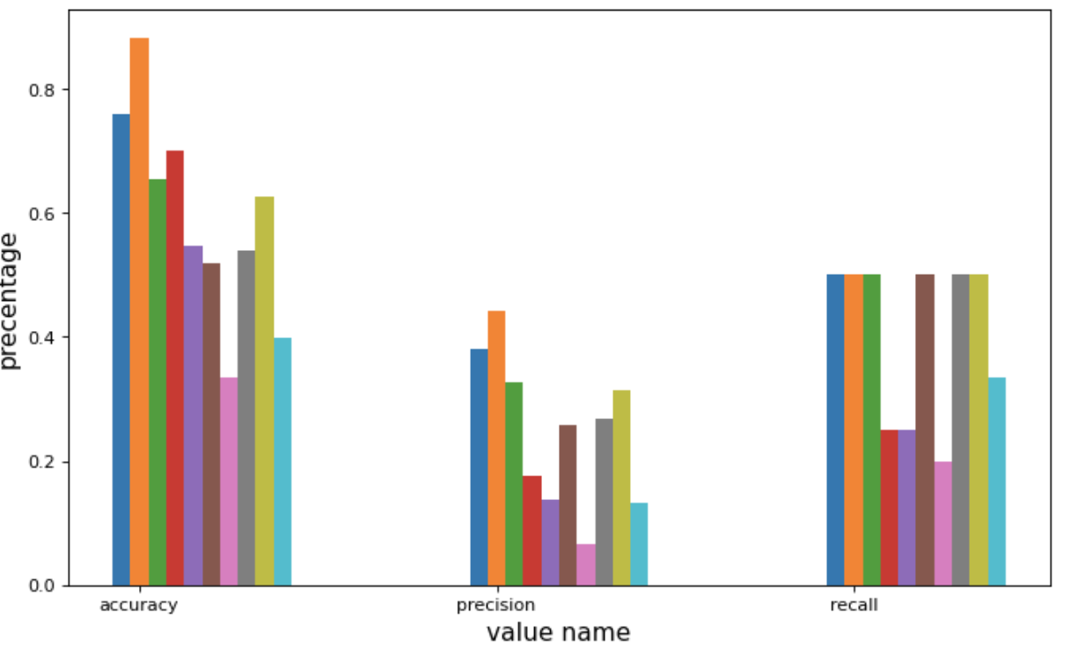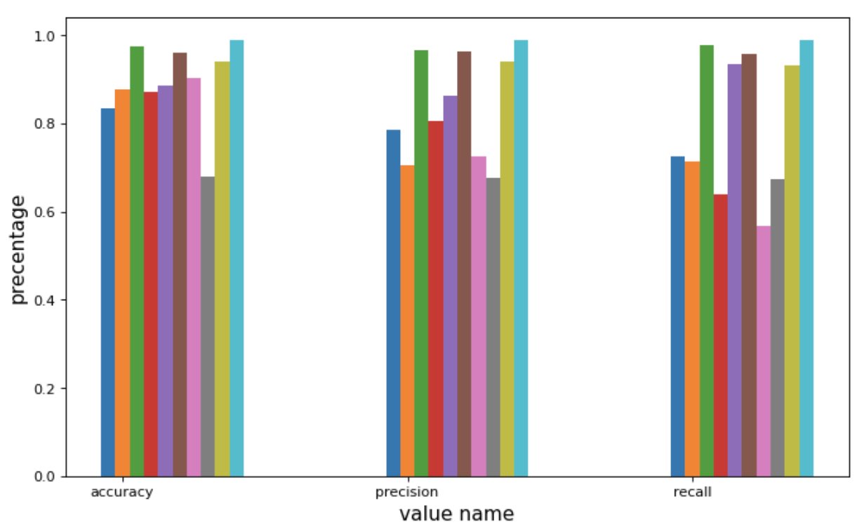

All the evaluation values that implement 0R baseline on 10 datasets

All the evaluation values that implement NB classifier on 10 datasets

The graph on the left is all the evaluation values that implement 0R baseline.

The graph on the right is all the evaluation values implement Naive Bayes classifier.

As we can observe

For the 0R graph, that the range of accuracy is from 0.333 - 0.883

For the Naive babes classifier, the range of accuracy is from 0.678 - 0.989

Also, for the grey bar in the NB graphs is the somerville.data evaluation, This is a dateset with only 143 instance and only 6 attributes. Not enough number of instance and attributes will seriously affect Naie Bayes Classifier accuracy. So the grey bar can be treated as an outlier.

Then the range of the accuracy are all above the 0.8

So Naive Bayes classifier accuracy is more stable than the baseline.

It is not hard to understand. The 0R baseline predict a class only depends on the proportion of the highest frequency class in the entire dataset. So that when proportion of the highest frequency class is high, then the accuracy is high. When the proportion of the highest frequency class is low, the the accuracy is low. The proportion of the highest frequency class varies from dataset to dataset, so that the accuracy of the 0R are not stable.

—————————————————————————————————————

**Improvement point 2:**

Baseline does not use the attribute to predict the result, so the accuracy is lower than the Naive Bayes.

The formula of the 0R Baseline: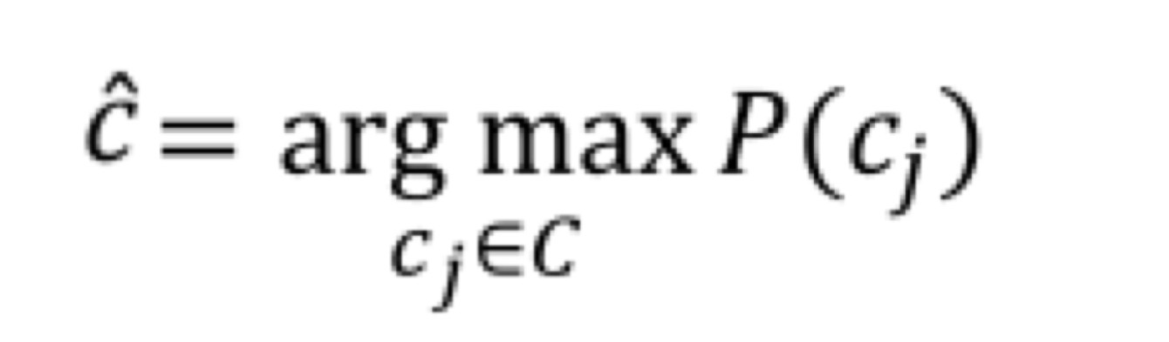

The formula of the Naive Bayes Classifier: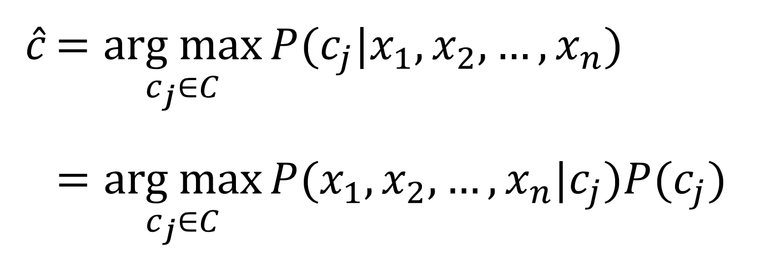

As we can see from the formula. The predict class of 0R is only base on the proportion of the highest frequency class. But the predict class of NB base on both attribute distribution and the class distribution.So when dataset class is uniformly distributed, NB Classifier would be more accurate.

Take the wine.data as example: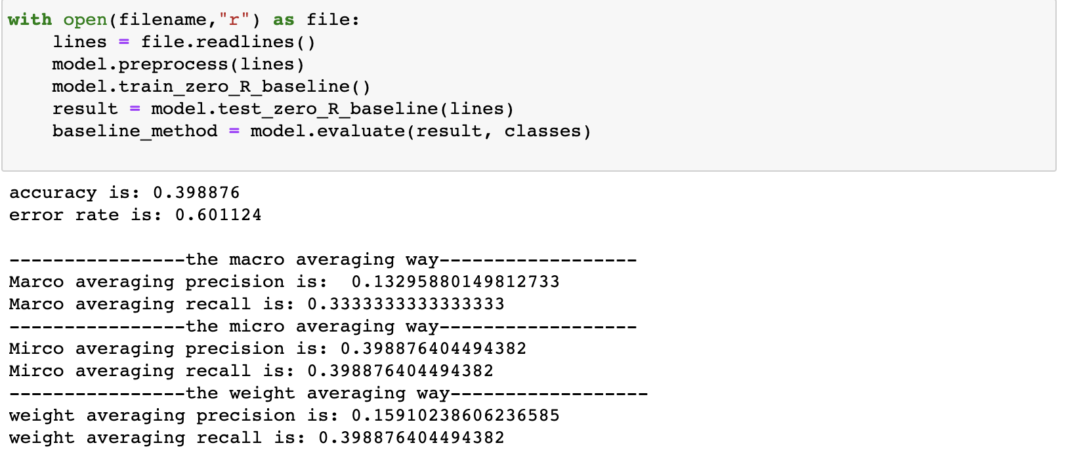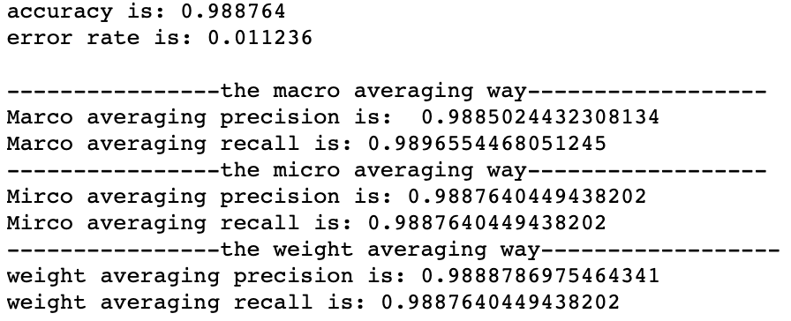

the evaluation result by implement NB classifier on wine.data

the evaluation result by implement 0R on wine.data

There are three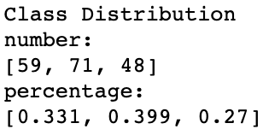 class in dataset. And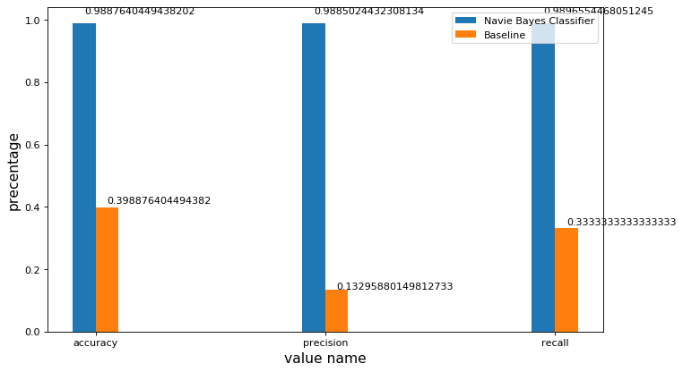 they are relatively uniformly distributed.

So the accuracy of the 0R is very low.

But when we read deeper in the dataset. We can see that nearly all the attribute are normal distribution (An example attribute distribution of the different class in wine.data on the left),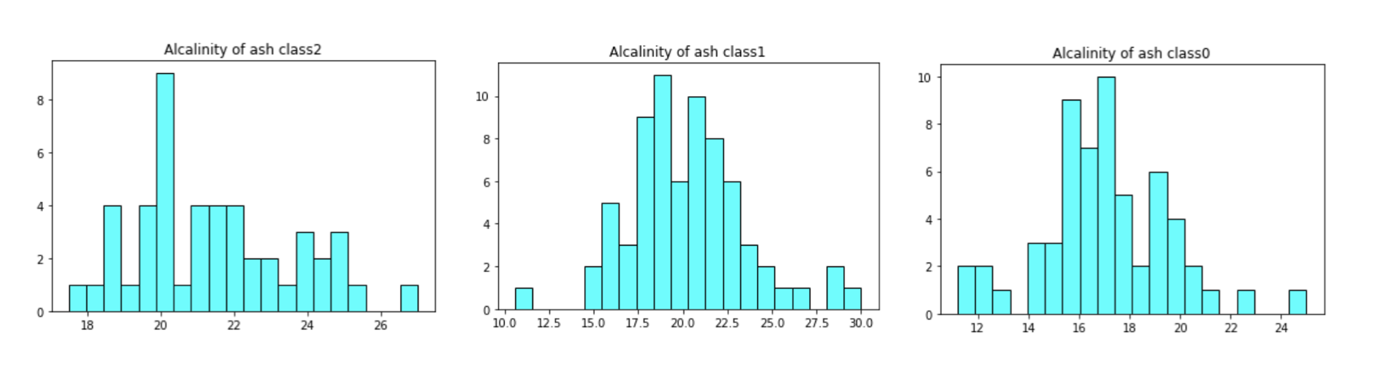 which is a very useful information to predict class.

Naive Bayes classifier used this

information, make accuracy much higher than 0R baseline model.

An attribute distribution of the different class in wine.data

The Naive Bayes Classifier use attribute distribution make a more accurate evaluation than the 0R baseline

—————————————————————————————————————

**Improvement point 3:**

The recall and precision of 0R are actually meaningless, Naive Bayes Classifier’s recall and precision give us more information about the dataset and prediction

Precision shows how often is the model correct, when it predicts a positive case

Recall shows what proportion of the true positive cases in the dataset was the model able to detect.

As I explained on the first part of analysis. We know 0R baseline only predict one class (most frequent class) for all dataset. So both precision and recall are meaningless, Because the only information it deliver are still the distribution of the class or even just number of class type.

While in the Naive Bayes classifier. It gives us more information about how the model work.

Sometime these two values are very important in some case.

For example,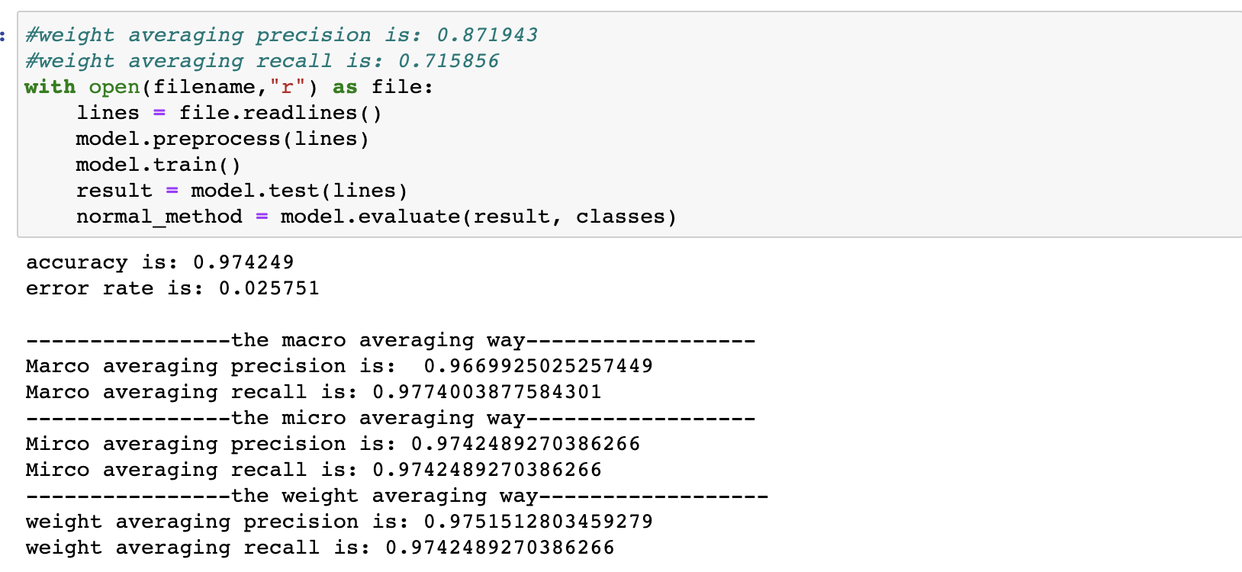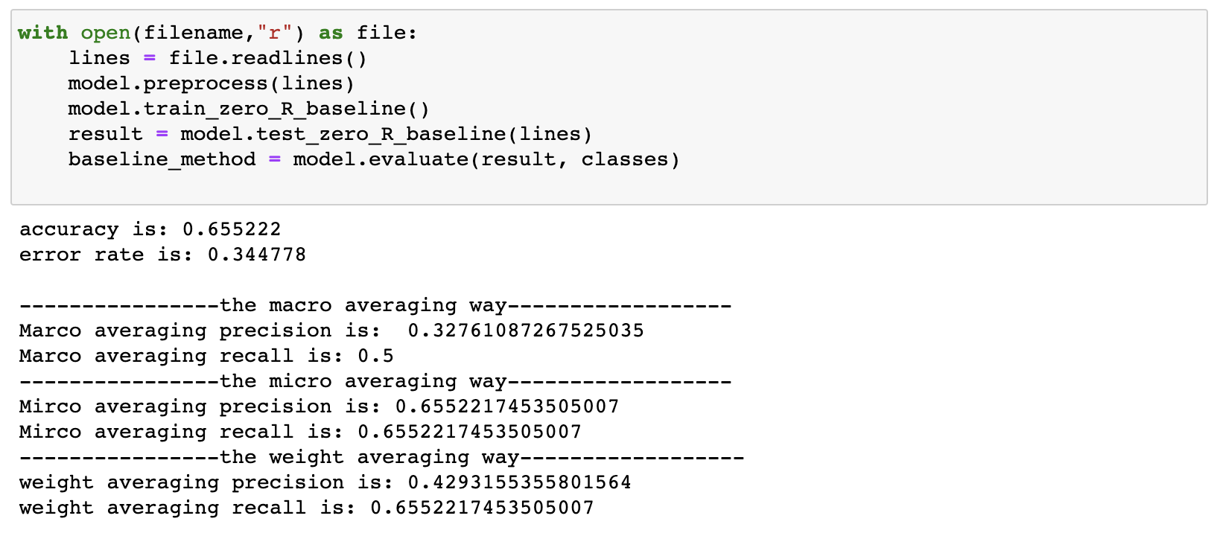 In the breast-cancer-wisconsin.data

Evaluation result of NB classifier

Evaluation result of 0R baseline

This dataset breast-cancer-wisconsin.data’s class is to evaluate whether the sample cancer are benign or malignant.

Precision shows how often is the model benign, when it predicts a benign case

And the Recall shows what proportion of the true benign cases in the dataset was the model able to detect.

These two values are key to tell people whether they should improve the model or increase the size of dataset, so that it do not give up any one malignant.

In the Naive Bayes Classifier, these two values give use this information

While in 0R baseline, precision only shows the how these two class benign or malignant distributed. Precision = (num_of_ benign/num_of_instance)/2. And the recall only show us how many classes type are there.

—————————————————————————————————————

**Conclusion**

The baseline performance varies across datasets, because the proportion of the highest frequency class, the number of class type, and the distribution of number of classes

Naive Bayes classifier improves on the baseline performance,

It make accuracy more stable than the baseline

It use the attribute to predict the result, make accuracy is higher than the baseline.

It makes recall and precision has more information about the dataset and prediction than the baseline